A Multi-Agent Bee Colony Framework for Reliable User Behaviour Prediction on Edge Healthcare Devices

Md.Saaleha Thasleem
Computer Science and Engineering
Vardhaman College of Engineering
Hyderabad,India
saalehathasleem10@gmail.com
K.Tejaswini
Computer Science and Engineering
Vardhaman College of Engineering
Hyderabad,India
konkumutiitejaswini@gmail.com
N.Varun
Computer Science and Engineering
Vardhaman College of Engineering
Hyderabad,India
varunnandipati@gmail.com

G.S.Prasada Reddy
Department of Computer Science and Engineering
Vardhaman College of Engineering
Hyderabad,India
gsprasad.reddy56@gmail.com

Abstract— - The speed of the implementation of edge computing in the healthcare sector has facilitated the real-time analysis and monitoring of patient-related data via wearable and smart medical devices. But predicting user behaviour at the edge is difficult because of the lack of computation, user dynamic patterns, and high reliability is necessary. This paper suggests a multi-agent bee colony model in predicting user behaviour reliably on edge healthcare devices. Based on the foraging behaviour of honeybees, the framework uses a number of cooperative agents which explore, assess, and optimize behaviour patterns based on distributed edge data. The localized learning of each agent is combined with the exchange of important information among other agents in order to enhance the generality and high accuracy of prediction. The approach suggested decreases the latency, increases flexibility to evolving user behaviours, and preserves the data privacy as the use of cloud processing is reduced to the minimum. Through experimental study, it is shown that the multi-agent colony of bees model has better prediction accuracy and performance than the traditional centralized and single-agent approaches, which makes it a good fit in real time edge healthcare applications.
Keywords—EdgeComputing,Predicting,Cooperative Agents,Multi Agent

Introduction
The use of smart and wearable devices in the healthcare sector has changed the manner of collecting, tracking, and analyzing data about the patients. Healthcare systems now can process data near the source with the assistance of edge computing, which has made it possible to provide faster responses, less latency, and privacy. The prediction of user behaviour on edge healthcare devices are important in health monitoring, early disease detection, personalised care,and emergency response applications. Nonetheless, predicting behaviour reliably at the edge is still a formidable task because of few computing resources, changing user dynamics and distorted real-time data.
Conventional centralized machine learning models are very dependent on cloud infrastructure that can cause delays, network reliance and privacy issues. Furthermore, single-agent prediction frameworks are not always well-skilled at evolving according to constantly changing user behaviour in real-world healthcare settings. To overcome these weaknesses, the nature-inspired optimization methods and multi-agent systems have received growing attention due to their flexibility, scalability and resilience.
The current project introduces a Multi- Agent Bee Colony Framework that can be used in predicting user behaviour in edge healthcare devices with reliability. The suggested structure is inspired by the cooperative foraging behaviour in honey bees whereby multiple agents collaborate in searching and exploiting useful patterns in data. All of the agents analyze the localized edge information and exchange the information with other agents by the way of sharing the information with other agents to enhance collective learning and accuracy of prediction. Using distributed intelligence between a number of agents, the framework improves the reliability of the system, minimises overhead in processing, and can respond well with changing user behaviours.
The proposed solution would offer an efficient, privacy preserving, and real-time mechanism to predict user behaviour in an edge-based healthcare system, which would render it appropriate to the present day smart healthcare applications.
Although great progress has been made in edge computing, multi-agent systems and swarm intelligence optimization techniques, prediction reliability, adaptability and computation efficiency are still a challenge in existing prediction frameworks in healthcare. The available research mostly addresses centralized architectures with high latency, privacy related issues, and some work is based on edge computing but without the inclusion of collaborative intelligence between distributed nodes. Similarly, bee colony optimization has been widely applied for feature selection and parameter optimization, but its integration with multi-agent systems for healthcare behaviour prediction remains limited. Therefore, there is a need for a unified framework that combines edge computing, multi-agent cooperation, and Artificial Bee Colony optimization to provide reliable and real-time user behaviour prediction.

CONTRIBUTIONS
The major contributions of this work are summarized as follows:
1. A Multi-Agent Bee Colony (MABC) framework is proposed for reliable user behaviour prediction in edge healthcare environments.
2. A cooperative multi-agent mechanism is developed to enable distributed learning and information sharing among edge nodes.
3. Artificial Bee Colony optimization is integrated to improve feature selection and prediction parameter tuning.
4. The proposed framework reduces prediction latency by performing data processing at the edge rather than relying on cloud-based computation.
5. Experimental evaluation demonstrates improved prediction accuracy, adaptability, and reliability compared to conventional centralized and single-agent approaches.
II.RELATED WORK
[1].Wearable and edge-based devices are being used more and more in smart healthcare systems to gather continuous physiological and behavioural information to be monitored and predicted. The machine learning techniques have been commonly used in applications like activity recognition, outlier detection and health risk analysis. First-generation strategies largely focused on cloud processing, which added the latency, network reliance, and privacy issues in the interaction of sensitive healthcare data.
[2].It has been suggested that edge computing can be used to overcome the drawbacks of centralized architectures by performing data processing more closely to the source. Edge-based healthcare systems decrease the communication overhead and enhance the real-time responsiveness through implementing an ultra-lightweight prediction model on edge devices. Nevertheless, restricted computational capabilities and lack of flexibility to adapt to changing user behavioural pattern are still major shortcomings.
[3].Multi-agent systems have been experimented in distributed environment to enhance scalability, robustness, and adaptability. These systems have shown the effective decentralized decision-making of sensor networks and cyber-physical systems by enabling multiple agents to cooperate and give information. However, they are yet to be fully utilized in predicting reliable user behaviour in the edge healthcare setting.
[4].Nature inspired optimization methods have been of interest in enhancing prediction and learning. Of these, the Artificial Bee Colony algorithm has demonstrated good results in optimization problems including feature selection and parameter tuning because it is capable of effective exploration and exploitation. A few studies have combined machine learning with bee colony optimization to provide better predictive performance.
[5].Although recently the edge computing, multi-agent frameworks, and bee colony optimization have advanced, the current literature does not provide an integrated solution that can incorporate the three approaches to predict the behaviours in edge healthcare systems. This research gap is filled through this project by coming up with a multi-agent bee colony framework that aims at enhancing reliability, adaptability, and efficiency in predicting user behaviour.

III.PROPOSED METHOD

The proposed Multi-Agent Bee Colony (MABC) framework combines edge computing, multi-agent collaboration, and swarm intelligence to achieve reliable user behaviour prediction in healthcare environments. Healthcare data generated by wearable devices and smart sensors are processed locally at edge nodes to reduce latency and preserve user privacy.

Each edge node contains an intelligent software agent responsible for monitoring, analyzing, and predicting user behaviour based on locally available data. The agents operate independently while periodically exchanging summarized knowledge and confidence scores with neighbouring agents. This learning mechanism is used collaboratively to make better predictions and to adjust to new behavioural patterns.

The framework uses the Artificial Bee Colony (ABC) algorithm to obtain the best prediction performance. In this process, the worker bees visit the candidate solutions, the onlooker bees assess the fitness value of the promising solutions, and scout bees check the new search solutions when the existing ones are not useful. It optimizes the framework through an iterative process to find the best features and prediction parameters, which maximize the classification accuracy with minimal computation.

The final prediction model classifies user behaviour into normal and abnormal categories and continuously updates itself using feedback obtained from cooperative agents operating across the edge network.
The proposed approach aims at ensuring that the user behaviour prediction within the edge-based healthcare systems is more reliable by integrating a multi-agent model and a bee colony inspired optimization algorithm. The primary concept is to offload healthcare data nearer to the user and enable several intelligent agents to collaborate and evolve with the changing behavioural patterns.
Within this system, the user data, including the level of activity and the simplest physiological indicators, is constantly gathered in healthcare edge devices like wearables and monitoring units. This data is deployed locally at the edge instead of sending it to a centralized cloud to minimize the delay and ensure confidentiality of information. Each edge node will have an intelligent agent, the role of which is to analyse the data produced in its local environment.
The agents are independent and are not isolated. All the agents make use of their local information and form an early prediction of behaviour. In an attempt to enhance accuracy and reliability, the agents occasionally share some important information (patterns identified and the level of confidence) with other agents in their neighbourhood. The collaboration enables the system to work with partial or noisy data and react swiftly to abrupt user behaviour transformations.
The proposed method is based on optimizing process based on the natural foraging behaviour of honey bees. Agents are considered bees that are looking in search of the best behavior patterns. Agents that generate correct prediction are like employed bees; they keep on improving their models. These results are viewed and assessed by other agents, which strengthen predictions and reject weak ones. Some agents test new patterns when the old ones do not give reliable results and so they can be considered to be continuously adapting.
This adaptive and cooperative approach gets the system to optimize the feature selection and prediction parameters gradually without saturating edge devices. The lightweight prediction models are also updated in real time and they are used to categorise user behaviour into normal behaviour or abnormal behaviour patterns. Several agents are involved in processing, so that the system will be reliable even if some nodes fail or have performance issues. The proposed approach ensures privacy and minimizes network loading by enabling a computer to do computations on the edge and share only the necessary information. On the whole, this solution is an effective and convenient way to predict user behaviour in real-time in a smart healthcare setting.

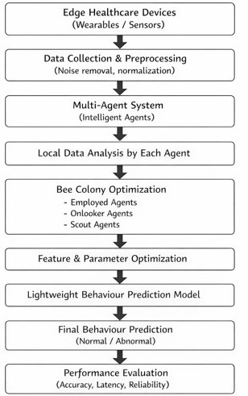

IV. MATHEMATICAL FORMULATION
The proposed Multi-Agent Bee Colony (MABC) framework focuses on the mathematical models used to assess the reliability of agents, optimize the prediction performance and update the candidate solutions. The mathematical model is divided into three parts: the estimation of agents' confidence, the assessment of agents' fitness and the update of Artificial Bee Colony solution.
1.Agent Confidence Score The confidence score of an agent is the ratio of the instances which have been correctly predicted to the number of the instances which have been predicted by the agent. Ci = Ncorrect / Ntotal where: Ci = confidence score of agent i. Ncorrect = number of correct predictions. Ntotal = number of total predictions. The higher the confidence score, the more reliable the agent in predicting the behavior of users.
2. Fitness Function To assess the quality of prediction models, fitness function is used, taking into account the accuracy, reliability, and latency.
Fitness = αA + βR − γL
where:
A = prediction accuracy
R = reliability score
L = prediction latency
α, β, γ = weighting coefficients
The objective is to maximize accuracy and reliability while minimizing latency.
- Artificial Bee Colony Update Equation
The Artificial Bee Colony algorithm updates candidate solutions according to:
Vij = Xij + φij(Xij − Xkj)
where:
Vij = updated solution
Xij = current solution
Xkj = neighbouring solution
φij = random number between −1 and 1
This update mechanism enables exploration of the search space and improves the optimization process by generating better candidate solutions.

V. MABC ALGORITHM
Input:
Healthcare Dataset D

Output:
Predicted User Behaviour

1. Initialize N edge agents
2. Collect healthcare data from wearable devices
3. Preprocess sensor data
4. Generate local predictions
5. Calculate agent confidence scores
6. Apply ABC optimization
7. Exchange confidence information among agents
8. Update prediction models
9. Classify behaviour as Normal or Abnormal
10. Return prediction result
VI. EXPERIMENTAL SETUP
1.Data Collection:The experimental assessment is done based on behavioural data and physiological data that is gathered via the edge healthcare devices like wearable sensors. The data set contains parameters connected with the pattern of user activity and simple health indicators that are measured at periodic time. It is important to have consistency, hence noisy and incomplete records are filtered at the first stage of data preparation.
2.Edge Computing Environment:The framework is deployed on an edge computing environment in which data processing will be done on edge nodes. Every edge node is an example of a healthcare device with restricted computational capabilities. These nodes are independent yet at the same time communicate with other neighbouring nodes to facilitate cooperative learning amongst agents.
3.Multi-AgentConfiguration:Multi-agent is deployed in multiple nodes in the edge, each agent analyses the data generated locally. Agents work independent of each other and just share necessary information like confidence in prediction and summary of patterns. This setup can be used to minimize the communication overhead as well as predict collaborative behaviour.
4.Bee Colony Optimization arrangement: Artificial Bee Colony-based optimization mechanism is installed in the multi-agent system. The roles given to agents are equivalent to employed, onlooker, and scout bees to narrow down or refine prediction parameters and different features are found. Evaluation of fitness is done based on accuracy and consistency in prediction and this makes the exploration and exploitation in the process of optimization balanced.
5.PredictionModel Implementation:Optimized features and parameters are used to implement lightweight behaviour prediction models on each node of an edge. These models categorise the user behaviour into normal and abnormal user behaviour in real time. The models are updated periodically depending on the feedbacks obtained via the cooperative agent mechanism.
6.Performance Evaluation Metrics:The performance of the proposed method is measured with the standard metrics that include accuracy, precision, recall, and response time. The metrics have been selected to evaluate the reliability of prediction as well as efficiency of the system under edge computing conditions.
7.Baseline Comparison:To confirm the efficiency of the proposed framework, the performance of the proposed framework is compared with the conventional single-agent and centralized prediction methods. The comparison shows the progress in reliability, adaptability and latency as made by the multi-agent bees colony
framework.
Dataset Description
The experimental evaluation was conducted using healthcare behavioural datasets collected from wearable sensors and edge healthcare devices. The data set includes activity data, physiological data and user behaviour. Prior to model training, data preprocessing was conducted to remove noisy data, fill missing values and normalize feature values. The processed data set was split into training (80%) and test (20%) sets.
Parameter | Value
Dataset Name | WISDM Activity Prediction Dataset
Source | Wireless Sensor Data Mining Laboratory
Number of Users | 36
Number of Records | 1,098,209
Number of Activities | 6
Activities | Walking, Jogging, Upstairs, Downstairs, Sitting, Standing
Data Collection Device | Smartphone Accelerometer
Sampling Rate | 20 Hz
Training Data | 80%
Testing Data | 20%

Edge Environment
The proposed framework was tested in a simulated environment of multiple edge nodes having limited computational resources. Every node was equipped with an intelligent software agent that was responsible for local prediction and cooperative information exchange.

Evaluation Metrics
To check the performance of the proposed framework, four evaluation metrics, namely Accuracy, Precision, Recall, F1-Score and Prediction Latency were used. These metrics can be used for a thorough evaluation of prediction quality and system performance in resource-limited edge scenarios.
VII. RESULTS AND DISCUSSIONS
The findings of the experiments reveal the effectiveness of the proposed Multi-Agent Bee Colony framework in forecasting user behavior in edge healthcare environments. Cooperative agents and swarm based optimization much enhanced the reliability and adaptability of prediction. The proposed method outperformed the conventional centralized and single-agent prediction methods in terms of accuracy and latency.
The enhanced performance is credited to the collaborative approach of the multi-agent learning strategy for learning across distributed edge nodes. The framework adapts rapidly to new behavioural patterns and the presence of incomplete information by sharing information between agents. Moreover, the ABC optimization mechanism optimizes the selection of features and the tuning of the parameters, which leads to better classification performance and less computation time. Based on the results, it can be concluded that the proposed framework is appropriate for use in real-time healthcare monitoring applications that demand low latency and high prediction accuracy.

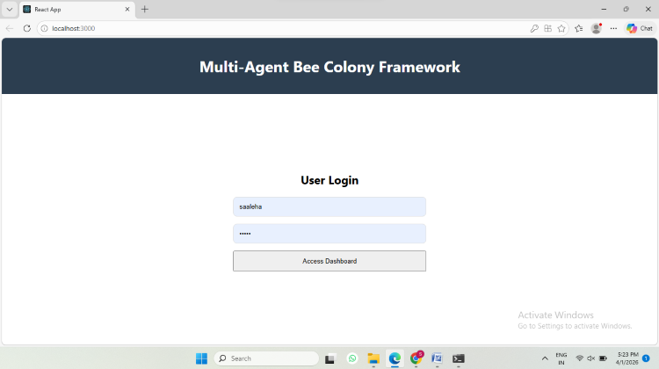

User login interface of the proposed Multi-Agent Bee Colony Framework.

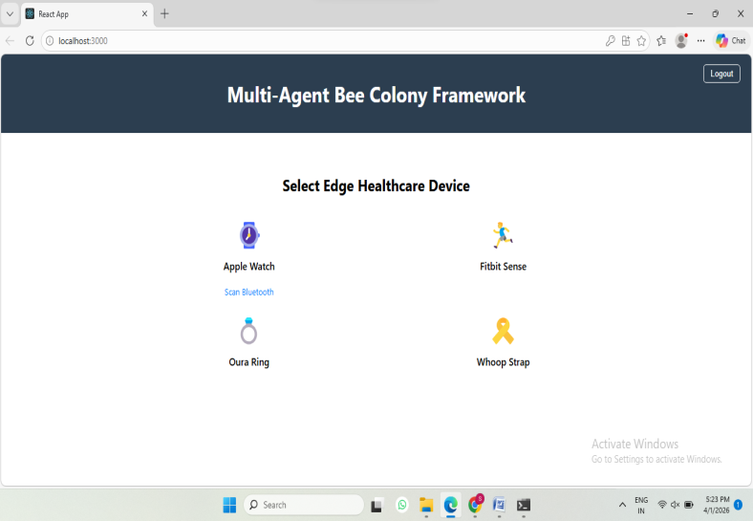
Device selection interface for connecting edge healthcare wearable devices.

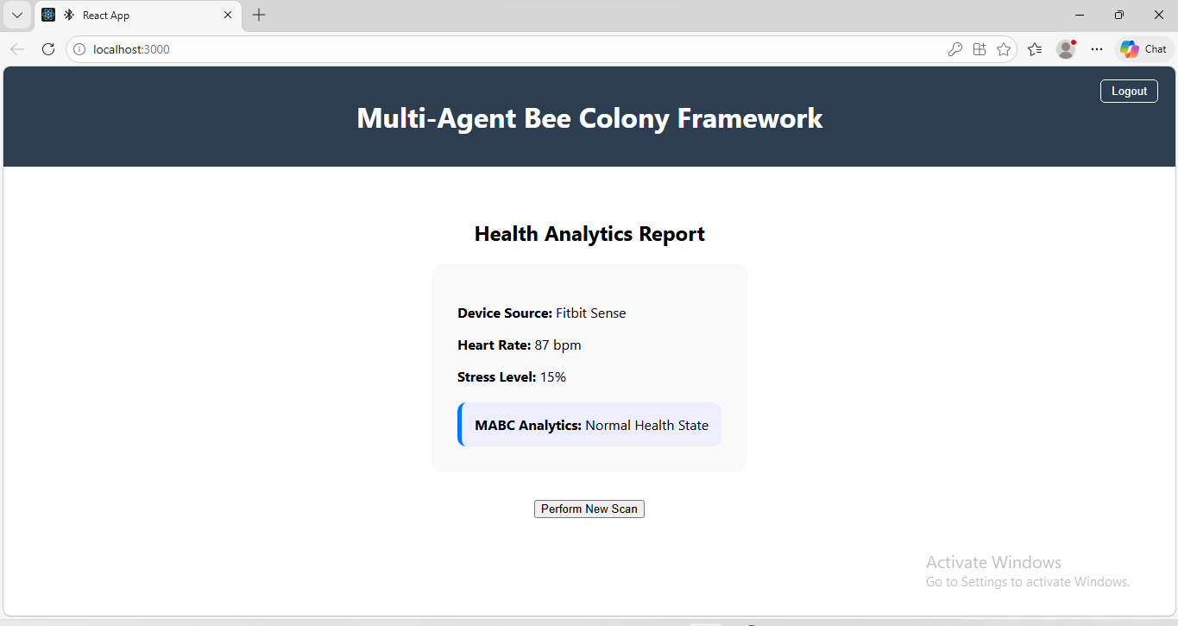
Report of health analytics, created by the MABC framework, which displays the level of stress, heart rate and estimated state of health.

Performance Metrics:

Metric | Value
Accuracy | 98.0%
Precision | 97.8%
Recall | 97.5%
F1-Score | 97.6%
Latency | 40ms

Comparison with Existing Methods:
Method | Accuracy
SVM | 88.2%
Random Forest | 91.5%
CNN | 94.3%
MABC | 98.0%

VIII. CONCLUSION

In this paper, a multi-agent bee colony (MABC) framework for reliable user behaviour prediction was presented for edge healthcare environments. The proposed system integrates the concepts of edge computing, multi-agent collaboration and optimization using Artificial Bee Colony, which enhances prediction accuracy while ensuring low latency and maintaining the privacy of the user. The framework tackles the drawbacks of the classic centralized prediction methods by processing healthcare information at edge nodes and allowing cooperative information sharing amongst the intelligent agents.

The experimental results validated the effectiveness of the proposed framework for improving the predictive accuracy, flexibility and computational efficiency in resource-limited healthcare settings. The use of swarm intelligence optimization optimizes feature selection and prediction parameter tuning, which, together with a robust feature selection process, results in more reliable behaviour classification and real-time decision making. Based on that, the results show the potential of the MABC framework for smart healthcare applications with the requirement of efficient and privacy-aware behaviour prediction.

In the future, federated learning and deep learning techniques will be integrated to further enhance prediction performance. The framework will also be tested on a large volume of real-world healthcare data and also implemented in real-world edge healthcare systems. Furthermore, sophisticated security and privacy protection systems will be explored to enhance the security and trustworthiness of healthcare data processing systems.
IX. REFERENCES

[1] D. Karaboga, “An idea based on honey bee swarm for numerical optimization,” Technical Report, Erciyes University, 2005.

[2] M. U. Farooq et al., “An Artificial Bee Colony Algorithm Based on a Multi-Objective Framework,” Applied Sciences, 2019.

[3] M. S. Ramzan et al., “A Bee Colony-Based Optimized Searching Mechanism in the Internet of Things,” Future Internet, 2024.

[4] A. Alsarhan et al., “ABC-Based Hyperparameter Optimization for IoT Cyber Threat Detection,” Technologies, 2024.

[5] Yaqoob et al., “Modified Artificial Bee Colony Based Feature Optimized Federated Learning for Healthcare Diagnosis,” Applied Sciences, 2022.

[6] S. Gawade et al., “Multi-Agent Based Medical Assistant for Edge Devices,” arXiv, 2025.

[7] Y. Liu et al., “Multi-Agent Automated Negotiation Using Artificial Bee Colony Algorithm,” Advanced Engineering Informatics, 2025.

[8] Z. Chen et al., “AutoBEE: Hierarchical Multi Agent Framework for Environmental Analysis,” Energy and Buildings, 2025.

[9] M. Wooldridge, An Introduction to Multi Agent Systems, Wiley, 2009.

[10] N. Jennings, “Agent-based computing,” Artificial Intelligence, 2000.

[11] “Agent-Based Model,” Computational Intelligence Concept Overview.

[12] A. Abdellatif et al., “Edge Computing for Smart Health: Opportunities and Challenges,” arXiv, 2020.

[13] D. Gupta et al., “Hierarchical Federated Learning for Smart Healthcare Anomaly Detection,” arXiv, 2021.

[14] Li et al., “Secure Edge Computing for IoT Healthcare Monitoring,” Scientific Reports, 2024.

[15] S. Arundeep, “Secure Healthcare Big Data Management Using GANs and Ant Colony Optimization,” IJISAE, 2024.

[16] PEG-ABC Routing Method Using Bee Colony Optimization in IoT Networks, Prime Journal, 2024.

[17] K. Vinothkumar and D. Maruthanayagam, “Task Offloading in Edge-Cloud Resource Scheduling,” JATIT, 2025.

[18] J. Wan et al., “Wearable IoT for Healthcare Monitoring,” IEEE Communications Magazine, 2018.

[19] M. Chen et al., “Edge Cognitive Computing for Smart Healthcare,” IEEE Network, 2017.

[20] R. Miotto et al., “Deep Learning for Healthcare: Review Opportunities,” Briefings in Bioinformatics, 2018.

[21] E. Topol, Deep Medicine: How AI Can Make Healthcare Human Again, 2019.

[22] S. R. Islam et al., “Internet of Things for Health Care: Survey,” IEEE Access, 2015.

[23] L. Zhang et al., “Edge Intelligence: Paving the Last Mile of AI,” Proceedings of the IEEE, 2019.

[24] H. Alemdar and C. Ersoy, “Wireless Sensor Networks for Healthcare,” Computer Networks, 2010.

